,
Crickhowell Primary School Prospectus
2025/26

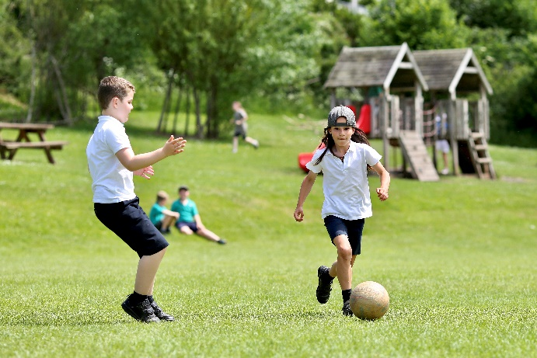

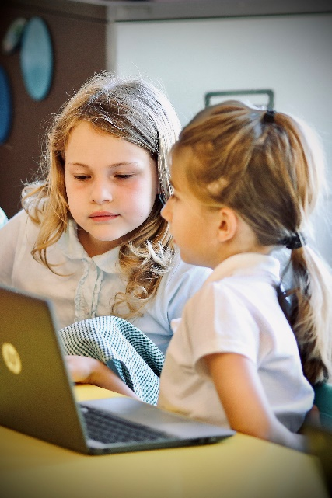

Welcome!
Thank you for wanting to find out more about Crickhowell Primary School.
Crickhowell Primary School offers a diverse range of opportunities for its pupils, both as part of the curriculum and as extra- curricular activities. We aim to provide children with the necessary skills, attitude and knowledge to equip them as learners for the 21st century, able to understand and adapt to the rapidly changing world around them.
Crickhowell is a Community School that places a strong emphasis on working with its many partners to develop exciting futures for the children in its care. Our vision is to create a happy, healthy, reflective and achieving School. A School which strives to get better year on year, is prepared to take risks to ensure all children can reach their potential. We work to instil lifelong values in our children and try to prepare them to be resilient, ambitious and considerate learners, ready to take their part in the wider world.
Mr R Francis- Head Teacher

Aims of the School
At Crickhowell Primary School we will…
- Provide a variety of high-quality learning and teaching experiences, which enable children to fulfil their potential.
- Encourage the children to identify what they know, what they need and want to know, guide them in their learning and help them reflect on their achievements.
- Deliver an inclusive, broad, balanced, creative and stimulating curriculum.
- Assist pupils in developing an understanding and appreciation of the culture, heritage and language of Wales, to value its place in the wider world and reflect this in daily school life.
- Encourage an awareness of the diversity of cultures and peoples within Wales and throughout the world.
- Ensure that pupils learn about their responsibility for the environment and their place in the wider community.
- Promote positive attitudes towards healthy eating and physical exercise.
- Create a positive learning environment in which all children feel valued, happy, safe and secure, and where excellent behaviour is actively encouraged.
- Cultivate ongoing mutual care and concern for others by working together, forming good relationships and sharing skills.
- Develop children as resilient, ambitious and considerate learners with a lifelong love of learning.

The School Building and Outdoor Environment
We are privileged to have an extensive school building that is well equipped to address the needs of the 21st century curriculum.
The accommodation includes:

- Ten classrooms
- Large multi-purpose hall with stage
- Separate school canteen/second hall
- School Library with its own electronic loan system
- Separate school offices, PPA room, head’s office and staff room
- Significant ICT equipment including: interactive whiteboards in every classroom; I-pads, laptops and chrome books

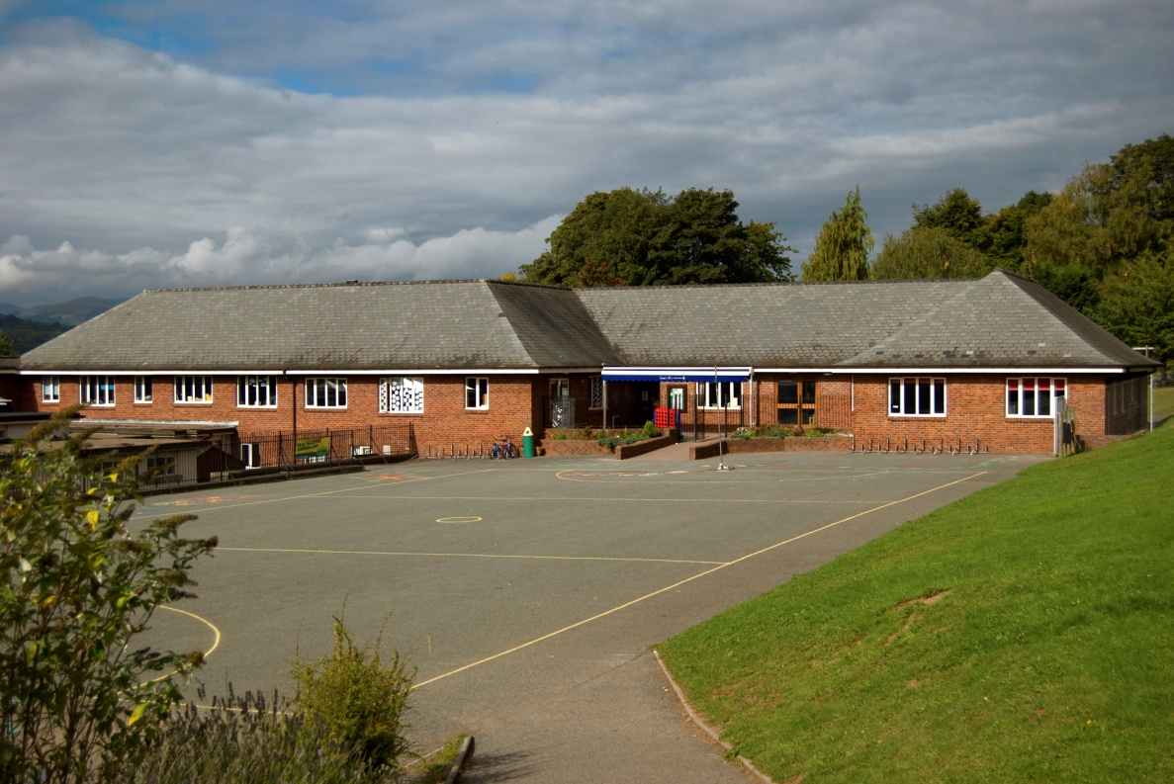
There has been extensive development of the school grounds in recent years through partnership working with parents, community groups and Environment Wales. The school’s environment has become a community resource with gardening facilities and allotments being used by the local playgroup as well as by our own classes. Willow domes and log circles further enhance the appearance of the site, whilst play equipment helps develop the children’s physical skills.

The Staffing Team
Mr R Francis-Head Teacher | Teaching Assistants  Miss GViveash  Miss L Alderman  Mrs Wendy Davies-HLTA  Mrs L Lewis  Mrs E Miles  Miss J Viveash  Mrs J Dykes  Mrs C Hill/Mrs R Gwillim (job share)  Mrs J Payne
Mr S Oram-Deputy Head, Yr 6 teacher
Mrs Hannah Davies -Lynott, Yr 5 teacher
Mrs Liz Kenchington (job share)
Miss A Weaver (ALNCo), yr 4 teacher
Mrs L Kenchington-Yr 4 Teachers (job share)
Mrs L Mc Pherson-Yr 3Teacher
Mrs K Davies-Yr 2 Teacher
Mrs E Picton-Evans Yr 1 Teacher
Miss G Joyce-Reception Teacher
 | Mrs Rebecca Merriman -School Administrator
 | Mrs Rhian Davies -Cook in Charge

The School Governors
- Name | - Type of Governor
Mr Rob Francis | Head Teacher
Mrs Ann Roe  Mrs Sue Ward | Community Governor  Community Governor
Mr John Morris | Community Governor
Mrs Nicky Webb | Parent Governor (Vice Chair)
Mrs David Barber | Parent Governor
Mrs Nicola Webb  Miss Sarah Farr | Parent Governor  Parent Governor
Miss Rachel Gwillim | Staff Governor
Mrs Ann Jeremiah | Minor Authority
Mr James Sercombe | LEA Governor
Mr Alun Tandy  Mrs L Mc Pherson  Mrs Sarah.Evans  Mrs Jade Land | Chair/Co-opted  Techer Governor  Community Governor  Clerk to the GB

Admissions
Parents considering sending their child to Crickhowell Primary are encouraged to make an appointment to view the school. Whilst this document can provide you with a good deal of information about the school and its operation, there is no substitute for first-hand experience, and we would welcome the opportunity to introduce you to the staff and children.

Children are required by law to attend school full time from the beginning of the term following their fifth birthday. All new pupils will be invited into school for a taster session during which more information about the school can be gained. There is Nursery Provision on the School site run by a Local Authority contracted supplier, Allsorts.

The formal admissions procedure is now handled by the Powys LA. Further information regarding admission arrangements and school’s information can be found in the Powys Handbook for Parents, which is available from the school office.

Transfer to High School
The majority of pupils transfer to Crickhowell High School at the end of Year 6. We enjoy close links with the High School and Year 6 children will engage in a number of transition activities which ease the move from primary to secondary school. These include sporting tournaments, taster days and transitions days! These events also provide Year 6 children with the opportunity to meet and mix with Year 6 children from the other primary schools in the cluster who will become their peers in Year 7. There are transition days in place for Year 5 to also experience High School life.

A small number of pupils will go on to attend King Henry VIII High School in Abergavenny, Haberdashers in Monmouth or Christ College in Brecon.
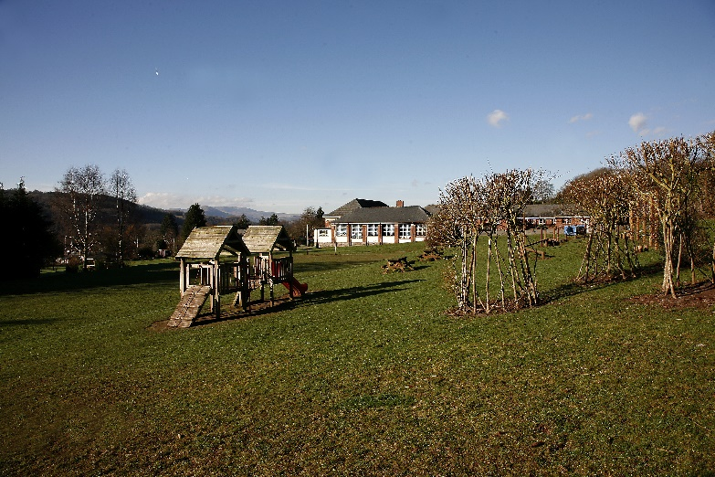

The School Day
All classes start at 9am and finish at 3.20pm

- Children should not arrive at school before 8.50 am, unless they are attending Breakfast Club, which starts at 8.00 am. The gates open at 8.50am
- At the beginning and end of the day parents are asked not to enter the school building unless they need to see a member of staff, which is best done at the end of the day.
- Always let the school know by telephone or written message if someone other than the usual carer will be collecting your child.
- We need to account for all pupil absences. Please inform the school of the reason for absence on the first morning so that we know your child is safe. If we do not hear from you by 9.30am, we will make contact with you by telephone to identify the reason for absence.

Breakfast and After School Clubs
We run a Breakfast Club which is open to all pupils. The first breakfast is served in the Canteen at 8.00 am and the last at 8.30 am. Breakfast consists of toast, cereal and fruit juice. There is a charge of £1.50 per pupil, £1.00 for additional siblings. We host an after-school club which runs from 3.20 pm to 5.15 pm at a cost of £5.00 per hour. Crickhowell Community Primary After School club is a non-profit, registered charity run by Mrs J.Dykes and Mrs Wendy Davies. The contact for booking is 07749531136.

Emergency School Closure
Occasionally, usually due to extremely poor weather conditions, it becomes necessary to close the school at short notice. In the event of this happening:
- A message will be placed on the homepage of the school website: www.crickhowell.powys.sch.uk
- A message will appear on Powys County Council’s website: www.powys.gov.uk
- A message will be sent to parents on schoop
- A message will be placed on the Friends of the School Facebook page
- Local media outlets will be informed: Radio Wales, Valleys Radio etc.

Holidays
We ask parents to arrange holidays in official school breaks. The School has been instructed by ERW (the regional education consortia) not to authorise holidays during term time. This means that any absence for the purpose of holidays during term time will be recorded as unauthorised. This will be reflected on the child’s end of term report and their school records. Parents are requested to inform the School if they intend to take a term-time holiday.

Transport and Access to the School
Powys County Council provide free transport for all pupils of primary age who live within the catchment area whose homes are more than two miles from school.

Children travelling from Cwrt –y-Gollen, Dan-y-Gollen and Llanbedr may be entitled to use the free school bus but must hold a current bus pass. These are obtained by completing an application form and returning it to the Transport Unit at County Hall, Llandrindod Wells.
Access to the school by car is via Llanbedr Road and then Oakfield Drive. Please drive considerately when approaching the school

Car parking at the school is difficult. Please do not park in a hazardous manner which could put pupils at risk. Please respect the BUS STOP, DISABLED and KEEP CLEAR markings in the car park at all times.

A pedestrian gate off Oakfield Drive serves pupils who live north of the A40. (Please note that this gate is padlocked between 9.10 am and 3.15pm.) Bicycles may be parked in the bike racks. They are not to be ridden in the school grounds.

School Security
The security of the children is taken very seriously by the staff and Governors of the school. For this reason, all visitors are expected to enter the school via the main entrance, to sign the visitor’s book and wear a visitor ID tag. All staff at school are also expected to wear ID tags. External gates are padlocked during the School day except for the main entrance. All staff wear lanyards showing their name and position in School. From September 2019, the gates with access to the School yard will only be opened at 8.50am.

School Meals
All meals are cooked on site in our kitchen, which is operated by Powys County Council’s Catering department.

Seasonal menus are given to the children, these follow a four-week cycle and offer hot meals with sandwiches or salad as alternatives. Special diets can be catered for by arrangement with canteen staff. Fruit juices may be purchased but water is also available free of charge. Children may bring in a packed lunch to eat in the dining hall if they prefer. We are a nut and egg free School so please try to remember this when preparing packed lunches.

We ask that dinner money for the week is paid for using the cashless system of ‘Parent Pay’.

Some children may be eligible for free school meals, details of eligibility and relevant forms are available from the School Office.

School Uniform
Boys and Girls:
Jade green sweatshirt with school badge,
White short sleeved polo shirt,
Navy trousers, skirt or pinafore dress.

Summer:
As above with the addition of green checked or
Striped dresses and optional baseball cap.

P.E:
White cotton T-Shirt and black shorts may be kept in school.
School PE shirts are available on the School Website.
Sweatshirts may be ordered through school every term.

Medication in School
The teachers and staff are not legally obliged to administer any medication to children during the school day. However, in exceptional circumstances where medication is essential and where it is difficult for parents to come into school to administer the medication to their child, the staff may agree to do so. Parents will be required to sign a form absolving the staff of responsibility in such a case.
Asthmatic children who need to carry inhalers to be used in school will also need their parents to sign a form to allow them to do so.
Any medication brought into school should be clearly marked with the child's name and handed in to the school office.

Home/School Contacts
Communication between home and school is essential to the happiness and success of the children. We encourage parents to maintain a dialogue with teachers and to make contact whenever the need arises, whether it is to raise an issue of concern, share information about events outside of school or to celebrate a child’s successes. Whatever the issue, parents are always welcome to contact the school. Parents are always welcome to visit, and an appointment can be made at the main office.
The best time to make contact with your child’s teacher is at the end of the school day. If the matter is urgent and you need to ring during the teaching day the best times to ring are at morning break, (10.40) and lunchtime (12.30). If there is no one available to answer the phone you will be able to leave a recorded message on our answer phone. This is checked for messages on a regular basis.
Mr Francis is always willing to meet with parents to discuss their concerns
A weekly school diary sheet is sent home via ‘Schoop’ every Friday. It is also emailed to those parents who have submitted their email addresses and published on the school blog. Latest events, newsletters and the School calendar can be viewed on the website: www.crickhowell.cpschool.co.uk
Meetings with parents are also held to discuss matters relating to the curriculum.

Home/School Agreement
Every school is required to produce a home-school agreement which outlines the commitment that both parties make to each other in ensuring a quality education for the children, in other words…
- The school’s responsibility to its pupils
- The responsibility of the pupil’s parents
- What the school expects of its pupils
A copy of the home-school agreement will be provided for parents to sign when they first admit their child to the school.

Friends and Family of Crickhowell Primary
The Friends and Family of Crickhowell Primary School is a home-school association and membership is automatic for all parents, guardians and/or carers of a pupil currently attending this school. Also involved are members of the teaching, non-teaching and support staff presently employed by the school. The association provides the opportunity for you to get involved with your child’s education and activities within the school.

Discipline and a Positive Learning Environment
At Crickhowell Primary School we aim to develop a sense of responsibility and mutual respect amongst the children where hard work, perseverance and regard for others are recognised and rewarded. We believe that this leads to the creation of an environment that is conducive to the children achieving their best.
The achievement of children is rewarded through praise, encouragement and a system of merits. A particularly good piece of work, the demonstration of concerted effort to achieve an objective or showing concern for the needs of a fellow pupil results in the child receiving a certificate which is presented during our Friday Good Work Assembly.
Class teachers also maintain their own systems of rewards and sanctions, which are consistent across School. There is a Class Dojo system that rewards the whole class for working together well.
Our School rules are SAFE, SECURE, ACHIEVE. Children are made aware that for every act of unacceptable behaviour as agreed by pupils there is a consequence, ranging from a ‘stop and think’ card to a ‘Yellow’ card with sanction. We believe that we have a duty to parents to inform them if persistent unacceptable behaviour occurs.

Children with Additional Learning Needs
At some time during their school life children may need extra help with their learning. We have a positive whole school approach to the education and development of all children and aim to give each child access as fully as possible to the whole curriculum by focusing on what they can do rather than what they cannot. We seek to enhance self-esteem and increase self-confidence and help children achieve their full potential.
Therefore, we believe early identification and suitable provision is very important for any child who has special educational needs.
Children requiring added help receive support from our Additional Needs Co-ordinator, Mrs Wendy Davies, either via provision made through their class teacher and Learning Support Assistant.
The school follows the thresholds, as set out in the Code of Practice for Special Educational Needs. Close links are maintained between Speech and Language Therapy Services, our Area Educational Psychologist and other outside agencies as necessary. These agencies may be involved in the development and maintenance of a child’s individual educational plan. Close communication is also kept between parents and staff, and parental involvement is seen as a vital part of the development of each child.

Children Looked After (CLA)
The school works with local authority support officers and social workers to provide support for pupils who are long or short term foster care. Our aim is to integrate, support and value these children in the same way we would any other child. Mr Francis the CLA coordinator and the first point of contact for foster parents wishing to enrol children at the school.

More Able and Talented Pupils
We are proud of the support that we provide for all pupils; this includes those who have been identified as excelling in particular areas or subjects. Our Support and Intervention Panel meets termly to consider the needs of all pupils and how we can best support them. For more able children this will include providing specific challenges within the classroom, differentiating tasks to a higher level or participation in one of the ‘Enrichment Workshops’ that we run for pupils in our school and other schools in the cluster on a yearly basis. Pupils identified as particularly gifted will have a More able and Talented Action Plan which is designed to ensure that their specific needs are met. Mr Oram overseas the MAT policy and procedure.

Curriculum for Wales
Our vision
“Learning for life”
Crickhowell Primary School offers a diverse range of opportunities for its pupils. We aim to provide children with positive teaching and learning experiences and essential skills associated with the 4 core purposes; which are fundamental to the New Curriculum for Wales. Crickhowell is a community school that places a strong emphasis on working with its many partners to develop exciting futures for the children in its care. Our vision is to create a happy, healthy, reflective and achieving school, where all children feel safe and secure. A school which strives to get better year on year so that all children can reach their full potential. We encourage pupils to become resilient, ambitious, and considerate with a lifelong love of learning.
Our inclusive curriculum
Our curriculum will raise the aspirations for all learners. As a school we have considered how all learners will be supported to realise the ambitions and aspirations of the four purposes, and to progress. We have considered our ALN provision and how we will meet the needs of different groups of learners.
The Four Purposes
The four purposes are the starting point and aspiration for our school curriculum design. Our school aims to support all learners to become:
• ambitious, capable learners, ready to learn throughout their lives •enterprising, creative contributors, ready to play a full part in life and work •ethical, informed citizens of Wales and the world
• healthy, confident individuals, ready to lead fulfilling lives as valued members of society
The statements of what matters
Our curriculum will provide rich opportunities and authentic learning experiences to develop the key concepts, knowledge and skills as described in the statements of what matters and in line with the Statements of What Matters Code.
Areas of Learning and Experience
Our curriculum will provide learning experiences through the 6 AoLEs of: • Languages, Literacy and Communication
• Expressive Arts
• Science and Technology
• Humanities
• Maths and Numeracy
• Health and Wellbeing
Learning, Progression and Assessment
Our curriculum will support learning through designing learning opportunities that draw upon the pedagogical principles.
Our curriculum, supported by effective learning and teaching enables learners to make meaningful progress. Over time our learners will
develop and improve their skills and knowledge. Our curriculum focuses on understanding what it means to make progress in a given Area or discipline and how learners should deepen and broaden their knowledge and understanding, skills and capacities, and attributes and dispositions and is informed by the Progression Code. This in turn supports our approach to assessment, the purpose of which is to inform planning for future learning. Assessment will be embedded as an intrinsic part of learning and teaching. All learners will be assessed on entry to the school.
Welsh and English
As an English medium school learning will take place in Welsh and English from the early years onwards.
Cross curricular skills
Our curriculum will develop the mandatory cross-curricular skills of literacy, numeracy and digital competence. Our curriculum will enable learners to develop competence and capability in these skills and to extend and apply them across all Areas. Learners will be given opportunities across the curriculum to:
• develop listening, reading, speaking and writing skills
• be able to use numbers and solve problems in real-life situations
• be confident users of a range of technologies to help them function and communicate effectively and make sense of the world
UNCRC / UNCPRD
Our school will promote knowledge and understanding of Part 1 of the UNCRC, and ofthe UNCRPD, among those who provide learning and teaching.
CWRE
Our curriculum will incorporate careers and work related experiences for all our learners.
RSE
Our school curriculum embraces the RSE guidance and mandatory RSE Code. Our RSE provision will have a positive and empowering role in our learners’ education and will play a vital role in supporting them to realise the four purposes as part of a whole-school approach. Helping learners to form and maintain a range of relationships, all based on mutual trust and respect, is the foundation of RSE. These relationships are critical to the development of emotional well-being, resilience and empathy.

RVE
Religion, values and ethics (RVE) is a statutory requirement of the Curriculum for Wales and is mandatory for all learners from ages 3 to 16. There is no parental right to request that a child is withdrawn from RVE in the Curriculum for Wales
As RVE is a locally determined subject, the agreed syllabus specifies what should be taught in RVE within the local authority and our curriculum will reflect this guidance.
Review and refinement
Our school curriculum will be kept under review in order to respond to the outputs of professional inquiry, the changing needs of learners and social contexts and needs. This will ensure our curriculum is both inclusive and responsive, meeting the needs of all learners. The reviews will take into account the views of stakeholders and will be signed off by the Governing Body. We will publish a summary of our curriculum and revise the summary if changes to the curriculum are made during the review process.

Assessment and Reporting to Parents
All our pupils are assessed on a continuous basis by their class teachers. There are a number of summative assessments that take place during the year, including those in reading, spelling and maths, which help us to track class and individual progress. Statutory assessments of reading and numeracy also take place each May to judge pupils’ progress against the requirements of the Literacy and Numeracy Framework. Cognitive Ability Test (CAT) are set in the Autumn Term for pupils in Year 4. These help to give us a clear picture of a pupil’s potential and are shared with parents during the Spring Term parents’ evening meetings.
A ‘Support and Intervention’ panel consisting of the Head, various members of the SLT and ALNCo , Assessment Coordinator, MAT coordinator meets termly to review pupil progress and identify children in need of extra support.
Children entering the Reception for the first time will undertake a Foundation Phase baseline assessment which informs teacher planning for the coming year.
A detailed report on a pupil’s work and progress will be sent home annually in July along with the children’s own evaluation of their progress. Parents are then given the opportunity to meet with teachers to discuss the report’s outcomes if they so wish.
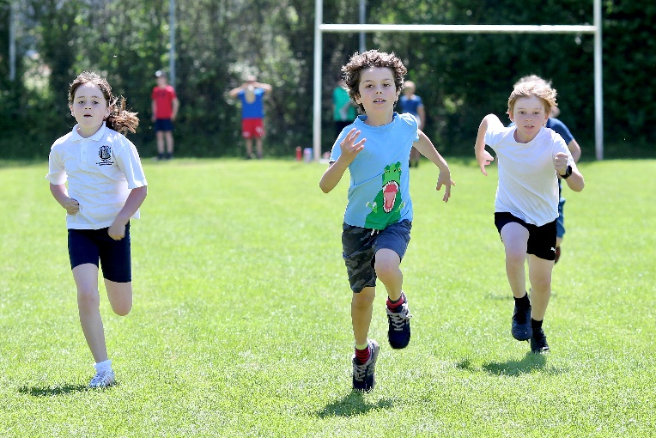
Consultative Parents Evenings provide opportunity for parents to see their child’s work and discuss progress with teachers. These are held in the Autumn and Spring Terms.

Extra-Curricular Activities
Our programme of extra-curricular activities take place during lunchtime or after school and varies from year to year, according to the time of year and strengths offered by staff and volunteers. Recent activities have included: netball, football, rugby, cross-country, choir, gardening, Drama, Lego, Cookery.

Charging Policy
A variety of educational visits and visitors take place at various times in order to back up the work undertaken in the classroom. Where costs are incurred, a voluntary contribution is requested of the parents.

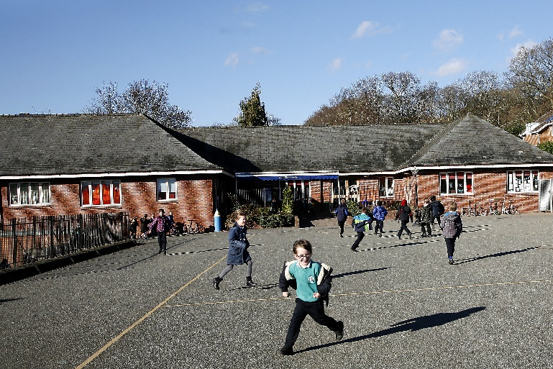
Cost per child =Total cost of the activity ÷ number of children taking part
Should not enough parents make voluntary contributions, then it may not be possible for the activity to go ahead. If parents have problems over contributions they should speak to the Head teacher.

Equal Opportunities
At Crickhowell Primary School…
- We do not discriminate against anyone, be they staff or pupil, on the grounds of their sex, race, colour, religion, nationality, ethnic or national origins.
- We promote the principles of fairness and justice for all through the education that we provide in our school.
- We ensure that all pupils have equal access to the full range of educational opportunities provided by the school.
- We constantly strive to remove any forms of indirect discrimination that may form barriers to learning.
- We ensure that all recruitment, employment, promotion and training systems are fair to all, and provide opportunities for everyone to achieve.
- We challenge stereotyping and prejudice whenever it occurs.
- We celebrate the cultural diversity of Wales and the UK and show respect for all minority groups.
- We are aware that prejudice and stereotyping is caused by low self-image and ignorance. Through positive educational experiences and support for each individual’s point of view, we aim to promote positive social attitudes and respect for all.

Disabled Access
Outside access via ramps is available to the main entrance, lower juniors block and infants block for children, parents and visitors with physical disabilities. The school has benefited from considerable building work which now makes internal access to all floors possible via a lift. Extensive facilities for assisting children with disabilities are now available.

Complaints Procedure
We hope that you will be happy with the education that your child receives in Crickhowell School. However, if you are dissatisfied in any way, you should first discuss the matter with the class teacher or the head teacher. If you are still not satisfied, the head teacher or chair of governors will give you details of the School complaints procedures. The person responsible for dealing directly with formal complaints is the Complaints Officer. It is inappropriate to discuss complaints with individual governors as they are the final arbiters on complaints.

Child Protection
As a caring school with direct responsibility for children, our first concern is the welfare of the child. The school has a legal obligation to contact other agencies where there are Child Protection concerns.
A school policy states our approach to the duty of the Governing Body to ensure that appropriate procedures are in place for the protection of children from abuse. Mr Francis, is the designated staff member for undertaking this responsibility. Mr S.Oram is the Deputy Child Protection Officer. The Chair of Governors, is the designated Governor.

Homework
Please encourage your child to develop a positive approach to homework by setting aside a time in the day when they can complete their tasks. All pupils are encouraged to read in their own time, every day. From any early age they bring home their reading books and we hope you will share the excitement of reading books together. Encourage your child to read things around them, e.g. labels, street names etc. as well as writing letters, stories, notes.
Homework assignments in English and Mathematics are given on a regular basis to all Infant and Junior pupils. Tasks may also be set related to topic and project work. Individual class teachers will correspond with parents outlining details.

Autumn Term 2025:
- Monday 1 September 2025 to Friday 24 October 2025
- Half Term - Monday 27 October 2025 to Friday 31 October 2025
- Monday 3 November 2025 to Friday 19 December 2025

Spring Term 2026:
- Monday 5 January 2026 to Friday 13 February 2026
- Half Term - Monday 16 February 2026 to Friday 20 February 2026
- Monday 23 February 2026 to Friday 27 March 2026

Summer Term 2026:
- Monday 13 April 2026 to Friday 22 May 2026
- Half-term - Monday 25 May 2026 to Friday 29 May 2026
- Monday 1 June 2026 to Friday 17 July 2026

Useful Dates:
*Good Friday: Friday 3 April 2026
*Easter Monday: Monday 6 April 2026
*May Day Bank Holiday: Monday 4 May 2026
*Spring Bank Holiday: Monday 25 May 2026
*Royal Welsh Show: Monday 20 July - Thursday 23 July 2026

How to Contact us
Crickhowell CP School
Oakfield Drive
Crickhowell
Powys NP8 1DY Tel. 01873 810300
Office Email: office@crickhowell.powys.sch.
Website: www.crickhowellcpschool.co.uk

